
Introducing
Basildon Health Centre

Our company, our mission

Thrive Health Hubs (THH) is a private company with NHS values.

THH is registered with the CQC as an Independent Healthcare Provider (IHP). As such THH is regulated in the same way as any healthcare provider including NHS Hospitals.

THH has been delivering NHS services in Essex for over 10 years with contracts up to 2040.

We are privately and locally owned and lead by an executive team of former NHS Directors. Each of our executive directors have worked at senior levels in the NHS including Hospitals and commissioning organisations in across Essex and London.

THH is committed to supporting the NHS and the local population by creating new facilities and services with the highest quality of care and patient experience. We are passionate about delivering equitable access to healthcare for all and will offer NHS funded as well as private services to meet growing demand locally. All patients will be treated in the same well-appointed facility delivering private-quality care and patient experience to NHS patients.

THH has committed to a set of values centred around working with the NHS and with local government to support local patients and the public:

  - Supporting NHS colleagues tackling backlogs and waiting lists.
  - Working in cooperation with the NHS to ensure a net increase in skills, capacity, students and wider workforce in the local area.
  - Working with local government to ensure we do whatever we can to be a boost to the economic viability of the areas in which we operate and the local environment through a focus on sustainability.
  - Ensuring the widest possible access for all patients, treating everyone as an individual who has a right to care which is higher than just a regulatory standard.
  - Working to ensure our staff are supported with clear plans with regards to their own career development, their personal wellbeing, and working to ensure our workforce is diverse and best reflects the communities we serve.

The recently published NHS “10-year health plan for England” sets out a clear aim to move services away from busy acute hospital sites and into community settings, closer to patients. The development of THH Basildon Health Centre and our wider programme is fully aligned with the strategic direction of the NHS and can facilitate and accelerate delivery of the NHS strategy in Essex.

Service overview for THH Basildon Health Centre
THH Basildon Health Centre is being developed in the former Debenhams store in Eastgate Shopping Centre.
This site was selected under our vision for “health on the high street”, specifically for its excellent public transport links and town centre location. The THH Basildon site benefits from proximity to a train station, bus terminal and extensive car parking. The town centre location will drive increased footfall in the town benefitting local business. This will also give our staff and patients easy access to town centre amenities and services.
The design, fixtures and finishes for the development have been specified for a premium environment throughout with natural materials and high-quality furniture and fixtures. Attending hospital for an appointment, test or treatment can be a stressful experience for patients and our approach is intended to make all patients comfortable and at ease.
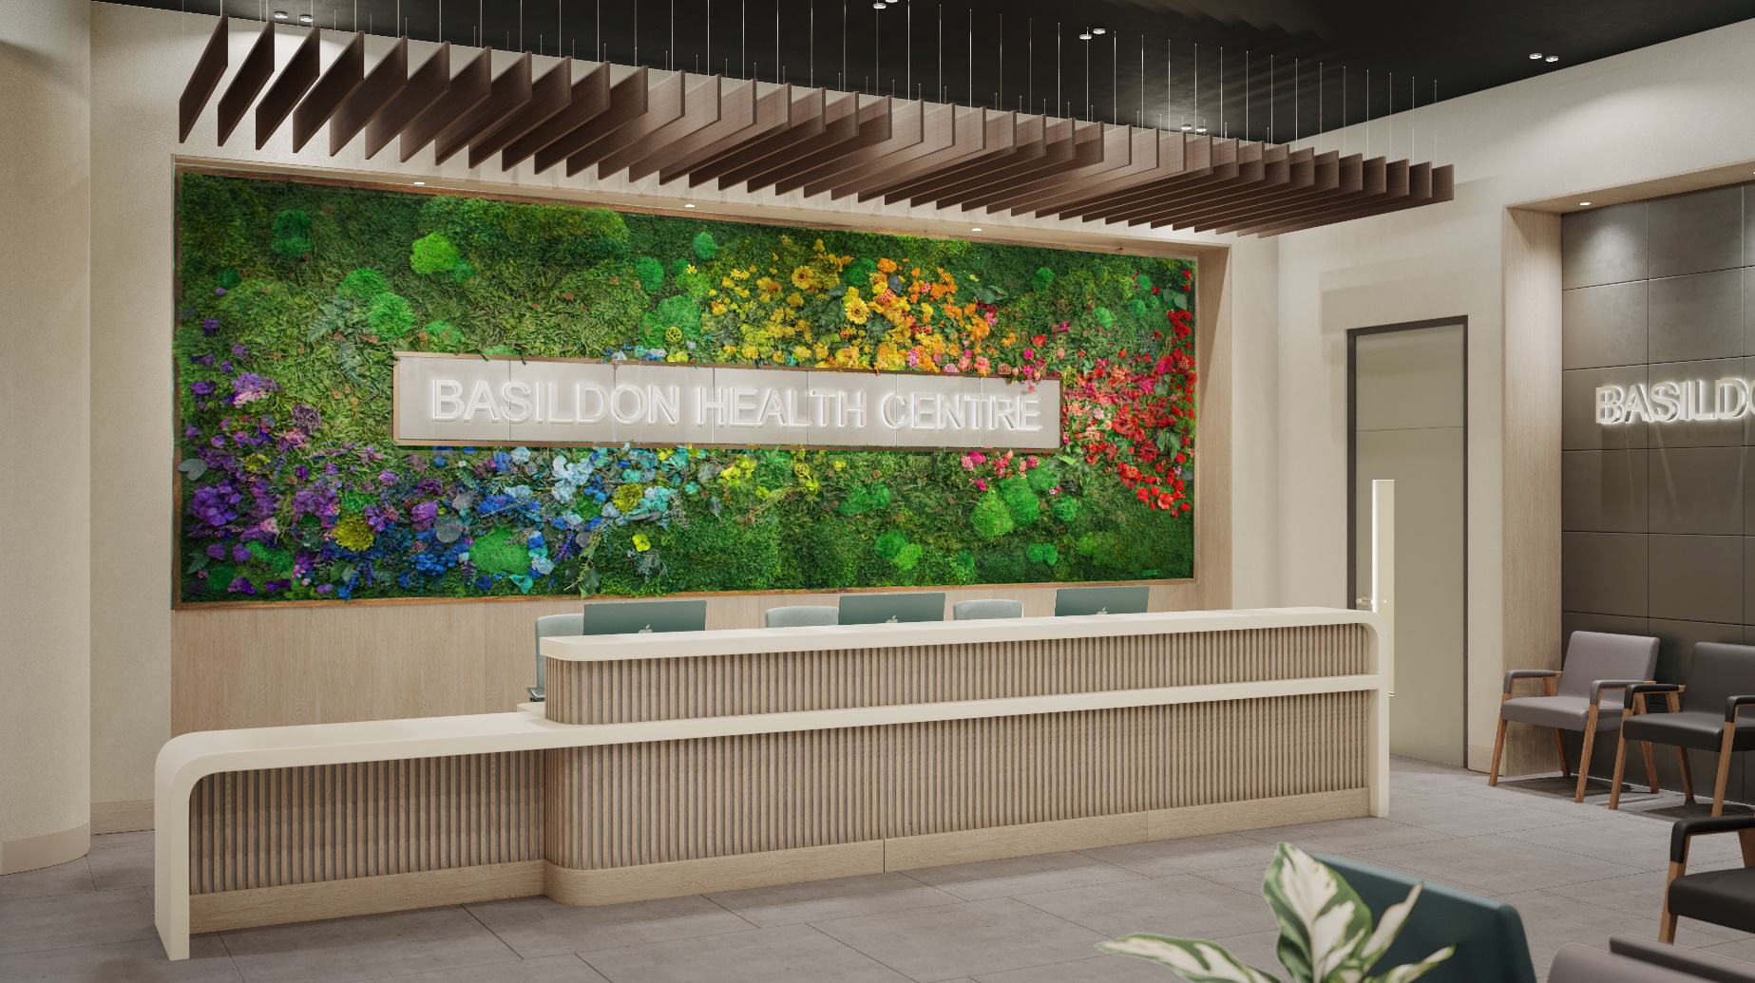
The first phase of Basildon Health Centre will be completing in Summer 2026. This will deliver core health services on the ground floor including:
- CT scanner
- MRI scanner
- X-ray
- Ultrasound scan rooms
- Echocardiography
- Respiratory diagnostics
- Outpatient department offering range of GP and specialist clinics
- Operating theatres and minor procedures

THH Basildon will be available as a choice for GPs to make NHS referrals into a range of specialist services. This alternative referral route will offer patients choice of a new location that may be easier for them to access and have shorter waiting times. These will incorporate streamlined pathways and one-stop services.
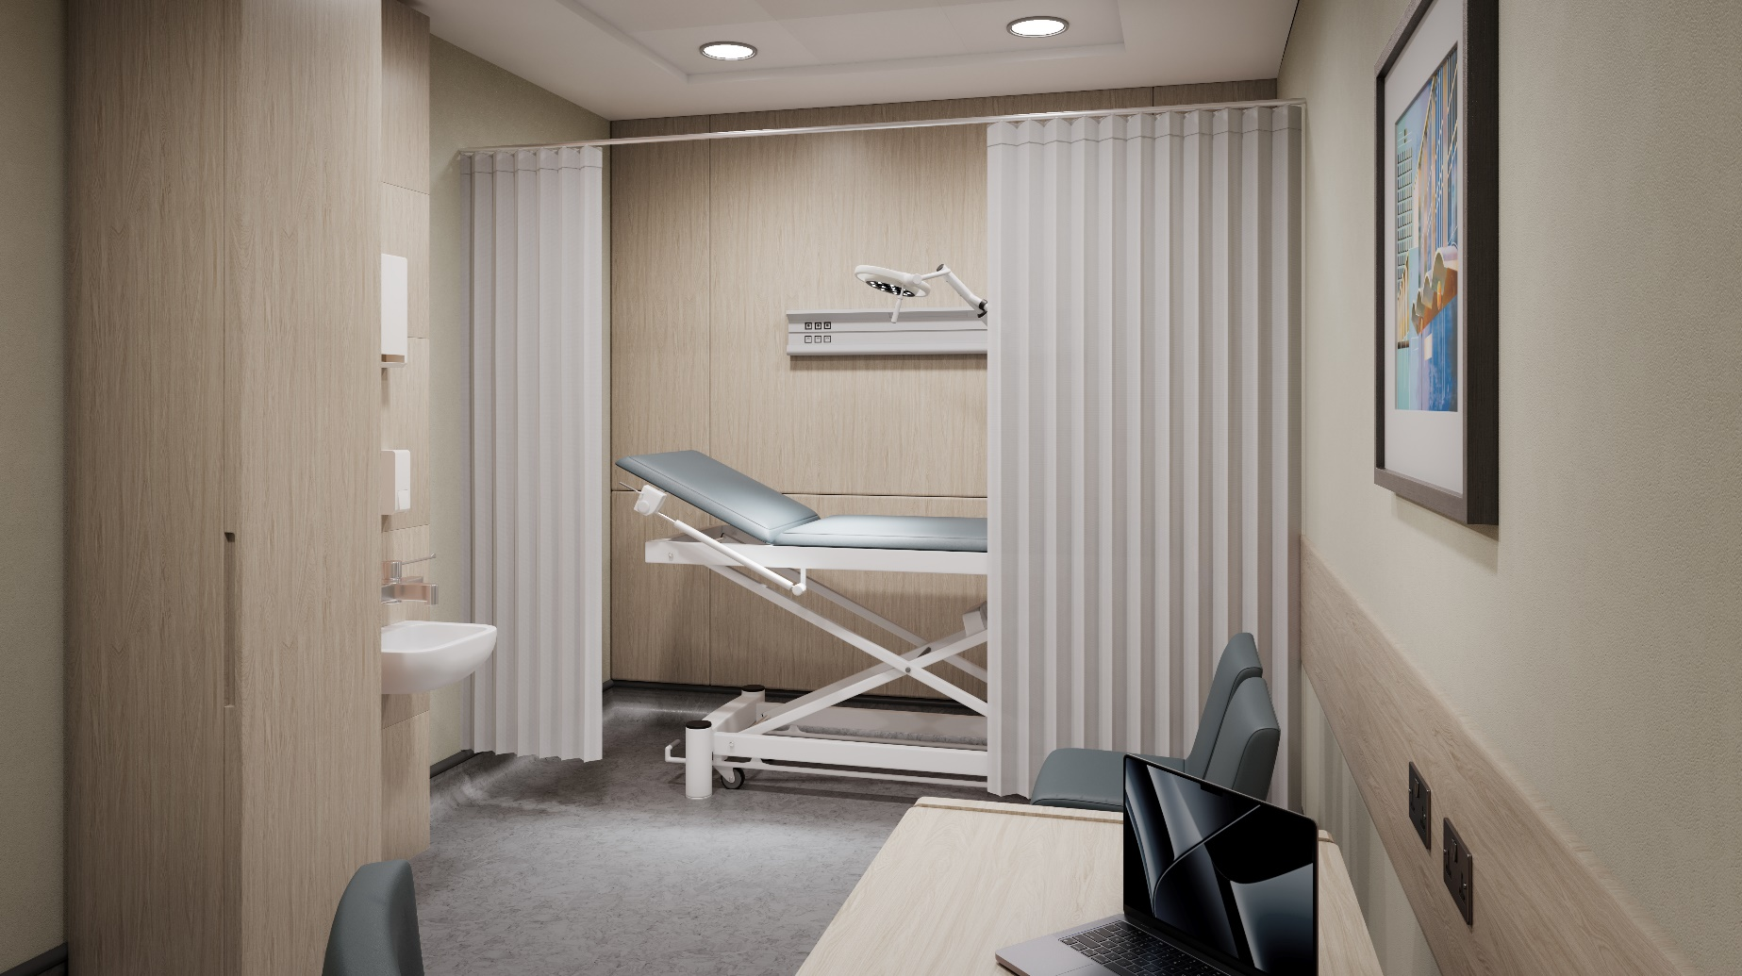

THH will offer capacity directly to the NHS to support with any existing backlogs that may exist across the patient pathway in outpatients, diagnostics and theatres.
Future phases of the health centre will develop the basement and upper floors incorporating further specialist diagnostic services, a rehabilitation gym, staff training facilities, overnight beds and further specialist surgical facilities.
The phase 1 health centre development will create over 50,000 appointments per annum in phase 1 increasing to 150,000 appointments per annum when the centre is fully developed.
The health centre will create up to 350 new jobs in the town once fully developed incorporating 80 new jobs in the phase 1 development.
