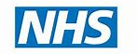


Thrive Health Hubs in partnership with the NHS
Introducing
Southend Health Centre
Incorporating
The Southend Community Diagnostic Centre
The Community Diagnostic Centre (CDC) Programme
The NHS Community Diagnostic Centre (CDC) programme is a national initiative to provide a wide range of elective (non-urgent) diagnostic tests and scans in community settings, away from busy hospitals.
These centres aim to speed up diagnosis, reduce waiting times, improve patient access, and decrease pressure on acute hospitals by bringing services closer to the public.
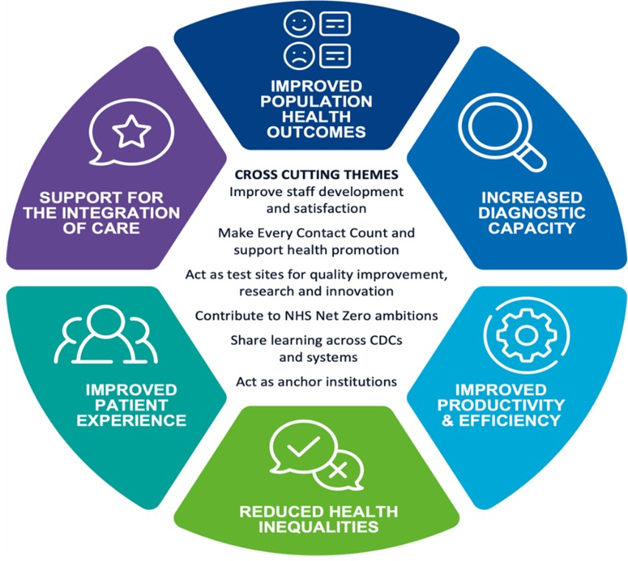

Clinical Service overview
The Southend CDC services include Xray, Ultrasound, Echocardiography and Respiratory Tests.
The Southend CDC is being developed in partnership between the NHS and Thrive Health Hubs (THH) to bring additional investment, expertise and innovation into local service delivery. THH are investing in further clinical services to be provided from the centre including CT, MRI, Day surgery, minor procedures and outpatient clinics.
CDC Services
- Xray
- Ultrasound
- Echo
- Respiratory
THH Southend Health Centre
- Day Surgery Theatres
- Outpatient Clinics
- Minor Procedures
- CT
- MRI

THH Southend Health Centre
THH Southend Health Centre is being developed in the former Argos store in Victoria Shopping Centre. This site was selected in partnership with the NHS under our vision for “health on the high street”, specifically for its excellent public transport links and town centre location. The THH Southend site benefits from proximity to a train station, bus stops and extensive car parking. The town centre location will drive increased footfall in the town benefitting local business. This will also give our staff and patients easy access to town centre amenities and services.
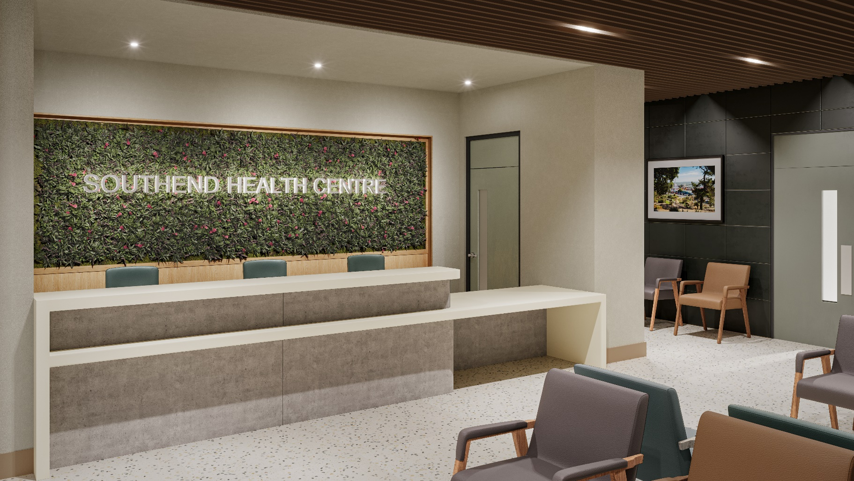
The design, fixtures and finishes for the development have been specified for a premium environment throughout with natural materials and high-quality furniture and fixtures. Our approach is intended to make all patients comfortable and at ease.

The first phase of Southend Health Centre will be completing in January 2026. This will deliver the NHS CDC services increasing capacity for the NHS and improving access for patients:
- X-ray
- Ultrasound
- Echocardiography
- Respiratory diagnostics

The second and final phase will complete in April 2026. This will introduce the additional services being provided from the centre:
- Day Surgery
- Outpatient clinics and Minor Procedures
- MRI and CT scanning
In total the health centre will deliver over 50,000 appointments per annum and create over 60 additional jobs.
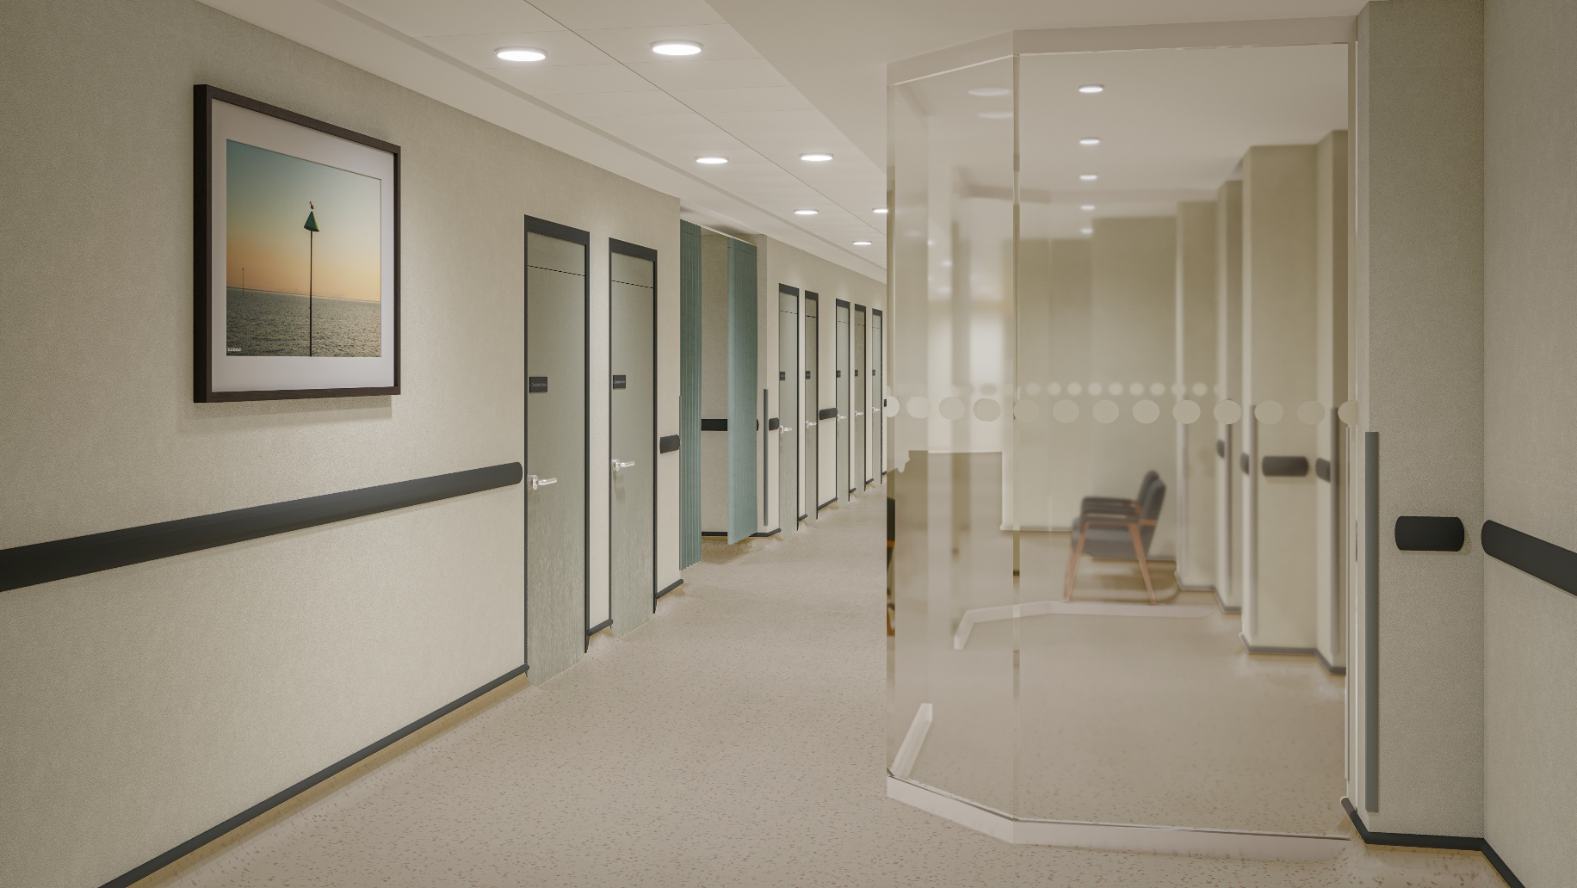
THH - our company, our mission
Thrive Health Hubs (THH) is a private company with NHS values. THH is registered with the CQC as an Independent Healthcare Provider (IHP) and regulated in the same way as NHS Hospitals. THH has been delivering NHS services in Essex for over 10 years.
THH is committed to supporting the NHS and the local population by creating new facilities and services with the highest quality of care and patient experience. We are passionate about delivering equitable access to healthcare for all.
THH has committed to a set of values centred around working with the NHS and with local government to support local patients and the public:
  - Supporting NHS colleagues tackling backlogs and waiting lists.
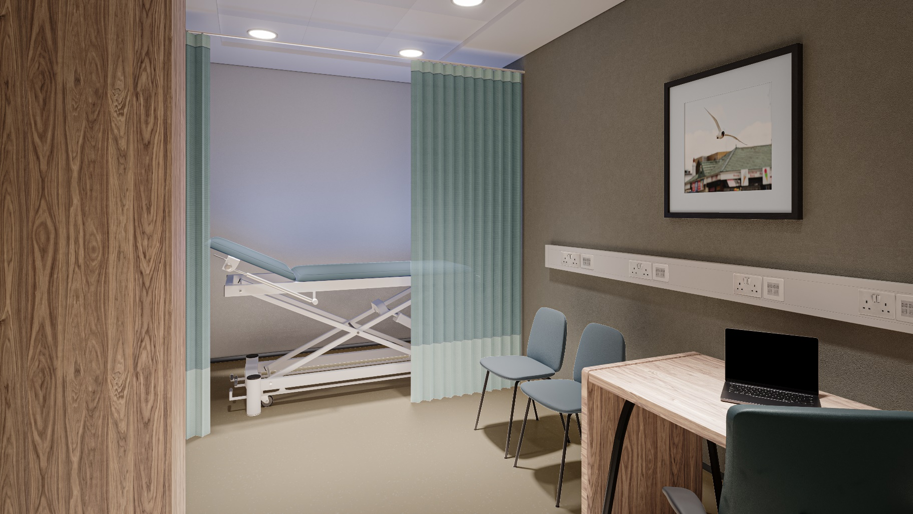
  - Working in cooperation with the NHS to ensure a net increase in skills, capacity, students and wider workforce in the local area.
  - Working with local government to boost the local economy and the local environment through a focus on sustainability.
  - Ensuring the widest possible access for all patients, treating everyone as an individual who has a right to care which is higher than just a regulatory standard.
  - Working to support our staff so they can provide the best care to our patients.

